Task 1: Helicopters Investigation

Outcomes: Science inquiry

AIM: Investigate the effect of changing one variable at a time.

- Follow the instructions below to make a paper helicopter
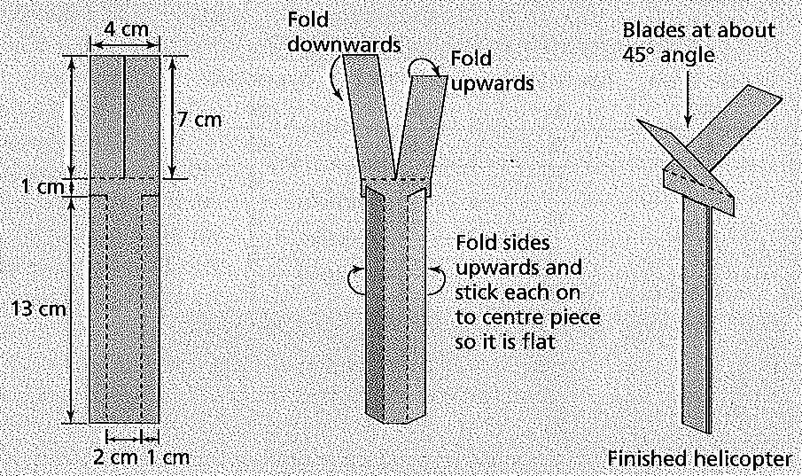

This is your control helicopter, that you will compare to all others.

Time how long it takes to fall a measured distance (eg 2 metres) three times.

Distance : ________________________ Time: Trial 1: _____________________

Trial 2: _____________________

Trial 3: ____________________

- Select one variable about your helicopter to change, so that you can see its effect.

I will change _____________________________________________________________

- Write a hypothesis (What do you think will happen? Try to relate the variable that you changed to the results that you expect.)

_____________________________________________________________________________________________________________________________________________________________________________________________________________________

- Make up two more different helicopters. Time how long each new helicopter takes to fall the same distance as your original helicopter. Repeat three times each and record the results in a table, including the original helicopter data.

Title:

Heading: | Heading:
Heading: | Trial 1 | Trial 2 | Trial 3 | Average

5. Think about the type of data that you recorded. What type of graph suits this data?

_______________________________________________________________________

- Graph your results below:

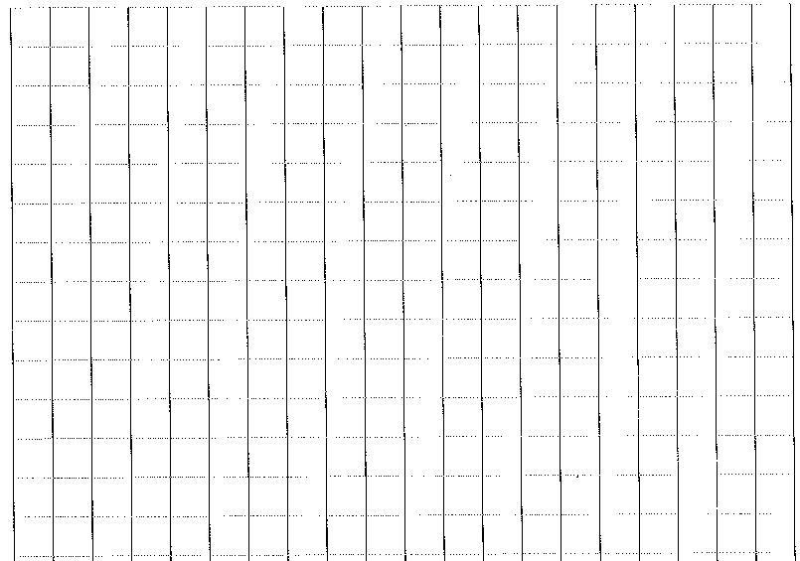

5. Graph you
RESULTS: Record your results in a table with appropriate title (ie relates variables) and column headings, including units. Include repeat trials and calculate averages. Graph your results (column or bar graphs for discrete data; line graphs for discrete data), include appropriate title and labelled axes with units.

DISCUSSION: What happened and why? Describe any patterns or trends in your results. Describe the shape of your graph. Include a summary of data (eg the lowest and highest average values). Explain your results using scientific knowledge and terminology.

EVALUATION: Did you have any difficulties conducting the investigation or sources of inaccuracies? How well did you control your variables or were there some that could not be controlled? How would you overcome difficulties or inaccuracies? Suggest improvements or further experiments that could be done.

CONCLUSION: Overall, what were the findings of your investigation (Was your hypothesis supported? Summarise the relationship between the independent and dependent variables).

- What is your independent (changed) variable and how did you measure it?
___________________________________________________________________________________________________________________________________________

- What is your dependent (effect) variable and how did you measure it?
______________________________________________________________________________________________________________________________________________

- List three controlled variables that you had to keep the same to make your experiment a fair test.
_____________________________________________________________________________________________________________________________________________________________________________________________________________________

- What happened and why? Describe and explain any trends in your results.
___________________________________________________________________________________________________________________________________________________________________________________________________________________________________________________________________________________________________________________________________________________________________

- Did you have any difficulties or problems with your experiment?
____________________________________________________________________________________________________________________________________________________________________________________________________________________________________________________________________________________________

- How would you fix this problem if you did this experiment again?
____________________________________________________________________________________________________________________________________________________________________________________________________________________________________________________________________________________________

- Write a conclusion for your investigation. (What was the overall finding? Was your hypothesis supported or not supported?)
_____________________________________________________________________________________________________________________________________________________________________________________________________________________

 |  | Mark Allocation | Mark
Hypothesis | - Hypothesis relates independent and dependent variables | 1
Variables | - Independent variable is identified  - Dependant variable is identified  - 1-3 controlled variables identified | 5
Results | - Table includes title which relates variables  - Columns relate to independent and dependent variables  - Columns have headings  - Headings include units | 4
Graph | - Graph title relates variables  - Graph type appropriate for data  - Axis correct orientation and labelled, including units  - Appropriate size and scale | 4
Discussion | - Results summarised and trends identified  - Explanation of results using scientific knowledge  - Difficulties or sources of error identified  - Suggestions for improvement | 4
Conclusion | - Summary of findings  - Hypothesis supported or not. | 2
Total
/20

